Deployment Guide

1. Access URL “<http://68.183.189.108:8080/>” and

UserID: admin, Password: admin then click [Manage App].

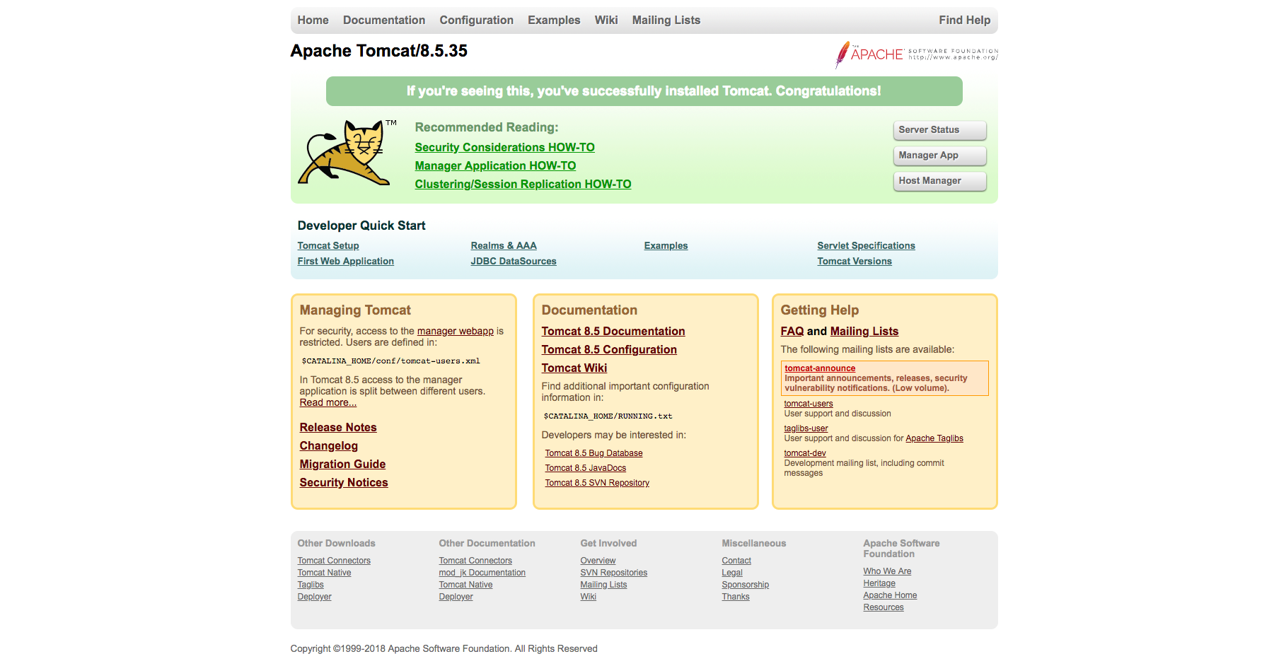

2. Stop service [[/bw0-web](http://68.183.189.35:8080/bw0-web/)] by click [stop] and [undeploy].

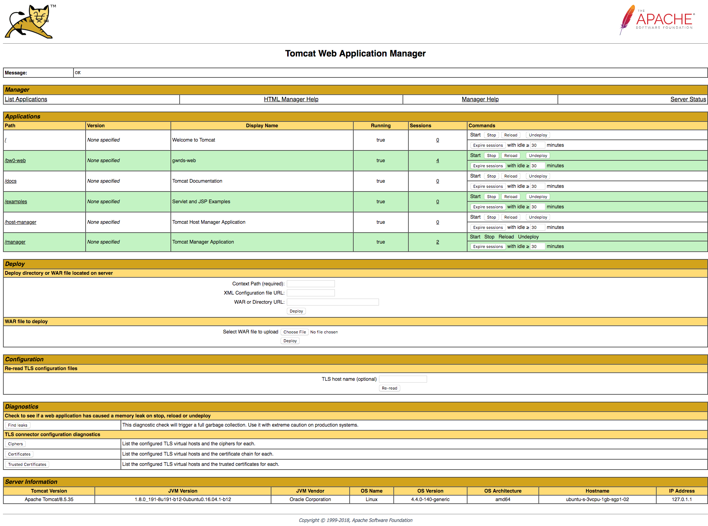

3 At [WAR file to deploy] click [choose file] then select WAR file and Click [Deploy].

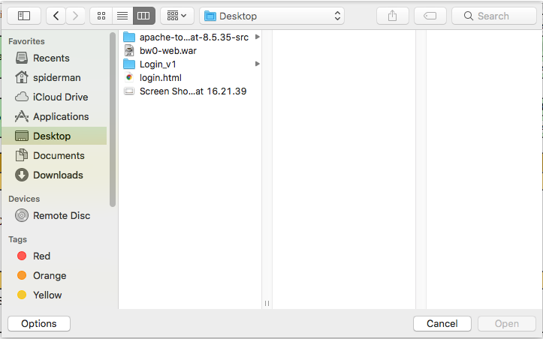

3. Application path will be appear to start.



|  |  |
| --- | --- |
|  |  |

4. Access URL “http://68.183.189.108:8080/bw0-web/” and fill in member login information then click [Login].

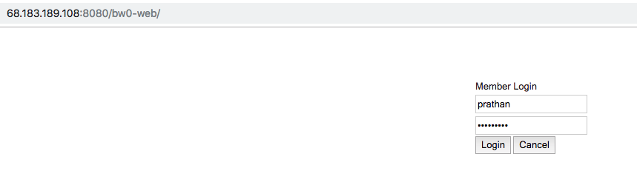

5. Click [Search] customers list will be appear in a list.

